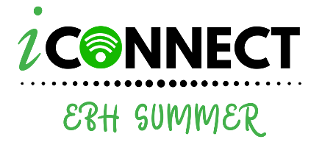
411 Washington Street, Boston, MA 02124
www.iConnectEBH.com

iConnect EBH Summer
July 7 – August 7, 2020

Registration Instructions

Complete & Submit the Registration Form to info.bakerhouse@gmail.com.
The form can also be completed online at www.iConnectEBH.com

For more information on the Camp, visit our website.
Please complete the form below:

Name of Student __________________________________________________ Gender:_______

Date of Birth______/_____/_____ Most Recent School

Circle Grade level student most recently passed: 7 6 5 4

Parent(s) or legal guardian #1

Name:__________________________________________________________________

Address:________________________________________________________________

Cell Phone#:(______)________-_____________Work Phone#:(______)________-_____________

Email:__________________________________________________________

Emergency Contact:_______________________________________________________

Emergency Contact Phone Number: (_____)_________-_________

Parent(s) or legal guardian #2

Name:__________________________________________________________________

Address:________________________________________________________________

Cell Phone#:(______)________-_____________Work Phone#:(______)________-_____________

Email:__________________________________________________________

Emergency Contact:_______________________________________________________

Emergency Contact Phone Number: (_____)_________-_________

___________________________ ___________________________ _________________
Parent/Guardian Signature Date

